|  |  |
| --- | --- |
| Activity | Data Type |
| Number of beatings from Wife | Discrete / Quantitative |
| Results of rolling a dice | Continuous / Quantitative |
| Weight of a person | Continuous / Quantitative |
| Weight of Gold | Continuous / Quantitative |
| Distance between two places | Continuous / Quantitative |
| Length of a leaf | Continuous / Quantitative |
| Dog's weight | Continuous / Quantitative |
| Blue Color | Discrete / Qualitative |
| Number of kids | Discrete / Quantitative |
| Number of tickets in Indian railways | Discrete / Quantitative |
| Number of times married | Discrete / Quantitative |
| Gender (Male or Female) | Discrete / Qualitative |

Q1) Identify the Data type for the Following:

Q2) Identify the Data types, which were among the following

Nominal, Ordinal, Interval, Ratio.

|  |  |
| --- | --- |
| Data | Data Type |
| Gender | Nominal |
| High School Class Ranking | Ordinal |
| Celsius Temperature | Interval |
| Weight | Ratio |
| Hair Color | Nominal |
| Socioeconomic Status | Ordinal |
| Fahrenheit Temperature | Interval |
| Height | Ratio |
| Type of living accommodation | Nominal |
| Level of Agreement | Nominal |
| IQ(Intelligence Scale) | Ratio |
| Sales Figures | Ratio |
| Blood Group | Nominal |
| Time Of Day | Ratio |
| Time on a Clock with Hands | Ratio |
| Number of Children | Ratio |
| Religious Preference | Ordinal |
| Barometer Pressure | Interval |
| SAT Scores | Ratio |
| Years of Education | Nominal |

Q3) Three Coins are tossed, find the probability that two heads and one tail are obtained?

**Ans :** Probability of single coins of Head or Tail is 1/2 . Either it is a head or tail probability is 1 / 2. Number of total Possible cases are 8.

Consider two heads and one tail of Probability is an event X. then

**Events = {** (H,H,T),(H,H,H),(H,T,H),(H,T,T),(T,H,H),(H,H,H),(T,T,T),(T,T,H)**}**

**P(X) =** 3/8 = 0.375

Q4) Two Dice are rolled, find the probability that sum is

1. Equal to 1
2. Less than or equal to 4
3. Sum is divisible by 2 and 3

**Ans :** Total Sum of the Probability is equal to 1. (a)

Q5) A bag contains 2 red, 3 green and 2 blue balls. Two balls are drawn at random. What is the probability that none of the balls drawn is blue?

**Ans :** Total number of balls are 2+3+2 = 7.

Probability of taking two balls from bags is 2/7.

Total Sum of the Probability is equal to 1.

Probability that none of the balls drawn is blue = **1- 2/7 = 5/7 = 0.714**

Q6) Calculate the Expected number of candies for a randomly selected child

Below are the probabilities of count of candies for children(ignoring the nature of the child-Generalized view)

|  |  |  |
| --- | --- | --- |
| CHILD | Candies count | Probability |
| A | 1 | 0.015 |
| B | 4 | 0.20 |
| C | 3 | 0.65 |
| D | 5 | 0.005 |
| E | 6 | 0.01 |
| F | 2 | 0.120 |

Child A – probability of having 1 candy = 0.015 = x.P(x) = 0.015

Child B – probability of having 4 candies = 0.20 = x.P(x) = 0.8

Child C – probability of having 3 candies = 0.65 = x.P(x) = 1.95

Child D – probability of having 5 candies = 0.005 = x.P(x) = 0.025

Child E – probability of having 6 candies = 0.01 = x.P(x) = 0.06

Child F – probability of having 2 candies = 0.12 = x.P(x) = 0.24

**Expected number of candies for a randomly selected child = 3.09**

Q7) Calculate Mean, Median, Mode, Variance, Standard Deviation, Range & comment about the values / draw inferences, for the given dataset

* For Points,Score,Weigh>

Find Mean, Median, Mode, Variance, Standard Deviation, and Range and also Comment about the values/ Draw some inferences.

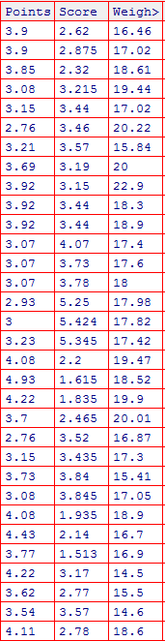

|  |  |  |  |
| --- | --- | --- | --- |
|  | **Points** | **Score** | **Weight** |
|  | 3.9 | 2.62 | 16.46 |
|  | 3.9 | 2.875 | 17.02 |
|  | 3.85 | 2.32 | 18.61 |
|  | 3.08 | 3.215 | 19.44 |
|  | 3.15 | 3.44 | 17.02 |
|  | 2.76 | 3.46 | 20.22 |
|  | 3.21 | 3.57 | 15.84 |
|  | 3.69 | 3.19 | 20 |
|  | 3.92 | 3.15 | 22.9 |
|  | 3.92 | 3.44 | 18.3 |
|  | 3.92 | 3.44 | 18.9 |
|  | 3.07 | 4.07 | 17.4 |
|  | 3.07 | 3.73 | 17.6 |
|  | 3.07 | 3.78 | 18 |
|  | 2.93 | 5.25 | 17.98 |
|  | 3 | 5.424 | 17.82 |
|  | 3.23 | 5.345 | 17.42 |
|  | 4.08 | 2.2 | 19.47 |
|  | 4.93 | 1.615 | 18.52 |
|  | 4.22 | 1.835 | 19.9 |
|  | 3.7 | 2.465 | 20.01 |
|  | 2.76 | 3.52 | 16.87 |
|  | 3.15 | 3.435 | 17.3 |
|  | 3.73 | 3.84 | 15.41 |
|  | 3.08 | 3.845 | 17.05 |
|  | 4.08 | 1.935 | 18.9 |
|  | 4.43 | 2.14 | 16.7 |
|  | 3.77 | 1.513 | 16.9 |
|  | 4.22 | 3.17 | 14.5 |
|  | 3.62 | 2.77 | 15.5 |
|  | 3.54 | 3.57 | 14.6 |
|  | 4.11 | 2.78 | 18.6 |
| Mean | 3.596563 | 3.21725 | 17.84875 |
| Median | 3.695 | 3.325 | 17.71 |
| Mode | 3.92 | 3.44 | 17.02 |
| Variance | 0.285881 | 0.957379 | 3.193166 |
| Standard Deviation | 0.534679 | 0.978457 | 1.786943 |
| Range | 2.17 | 3.911 | 8.4 |
| Maximum | 4.93 | 5.424 | 22.9 |
| Minimum | 2.76 | 1.513 | 14.5 |

**Comments:**

1st Moment of business decision values (Mean, Median, Mode) are very having closure difference. If you see the weight it was In between the 17 to 18.

2nd Moment of business decision, Weight Data were spreading in between the 14.5 to 22.9 and Standard deviation is also 1.78. When deviation is less then there will be lot chance to get the sample value very closure to actual value for the Population.

Q8) Calculate Expected Value for the problem below

1. The weights (X) of patients at a clinic (in pounds), are

108, 110, 123, 134, 135, 145, 167, 187, 199

Assume one of the patients is chosen at random. What is the Expected Value of the Weight of that patient?

**Ans :** Expected Value is average of all outcomes. Here we don’t have the probability of each weight of patient.

Average of (108+110+123+134+135+145+167+187+199)/9 is **145.33** is called as **Expected value.**

Q9) Look at the data given below. Plot the data, find the outliers and find out $μ, σ, σ^{2}$

|  |  |
| --- | --- |
| **Name of company** | **Measure X** |
| Allied Signal | 24.23% |
| Bankers Trust | 25.53% |
| General Mills | 25.41% |
| ITT Industries | 24.14% |
| J.P.Morgan& Co. | 29.62% |
| Lehman Brothers | 28.25% |
| Marriott | 25.81% |
| MCI | 24.39% |
| Merrill Lynch | 40.26% |
| Microsoft | 32.95% |
| Morgan Stanley | 91.36% |
| Sun Microsystems | 25.99% |
| Travelers | 39.42% |
| US Airways | 26.71% |
| Warner-Lambert | 35.00% |

**Ans:**

Mean : 33.27%

Median : 26.71%

Outlier : Morgan Stanley : 91.36%

Most of the Data were disbursed in the in 24% To 40% .Due to outlier Mean got more than Median.

|  |  |
| --- | --- |
| Mean | **33.27%** |
| Median | 26.71% |
| Variance | 0.0287147 |
| Standard Deviation | 0.169454 |
| Range | 0.6722 |

Please find the Visual diagram.

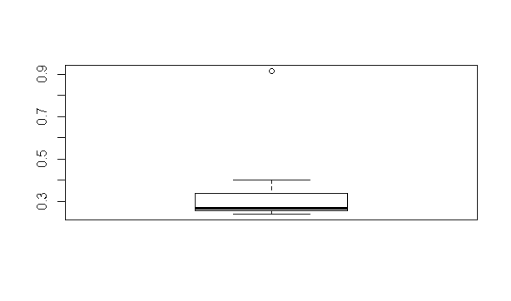

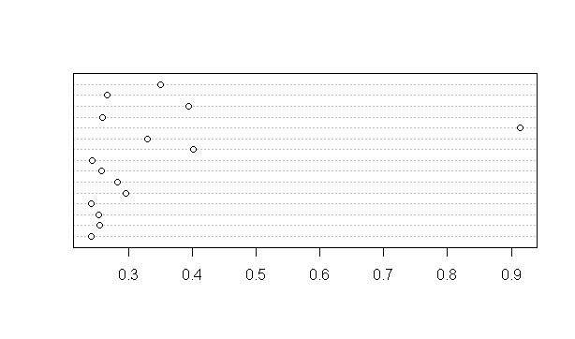

Q10) AT&T was running commercials in 1990 aimed at luring back customers who had switched to one of the other long-distance phone service providers. One such commercial shows a businessman trying to reach Phoenix and mistakenly getting Fiji, where a half-naked native on a beach responds incomprehensibly in Polynesian. When asked about this advertisement, AT&T admitted that the portrayed incident did not actually take place but added that this was an enactment of something that “could happen.” Suppose that one in 200 long-distance telephone calls is misdirected. What is the probability that at least one in five attempted telephone calls reaches the wrong number? (Assume independence of attempts.)

**Ans :**

The Probability of event E is P(E) = 1 / 200 for not misdirected.

Probability of misdirected is 1 – P(E) = 1 – 1/200 = 199/200.

Probability that at least one in 5 attempted call reaches the wrong number

= 1 - Probability that no attempted call reaches the wrong number

= 1 – (199/200)^5

= 0.025

Q11) Returns on a certain business venture, to the nearest $1,000, are known to follow the following probability distribution

|  |  |
| --- | --- |
| x | P(x) |
| -2,000 | 0.1 |
| -1,000 | 0.1 |
| 0 | 0.2 |
| 1000 | 0.2 |
| 2000 | 0.3 |
| 3000 | 0.1 |

1. What is the most likely monetary outcome of the business venture?

**Ans :** Outcome of the business venture is sum of X * P(X) is nothing but expected value.

= -$2000 * .10 + (-$1000) *.10 + 0 $ * .20 + $1000*.20 + $2000*.30+ $3000*.01

= -200$ -100$ + 200$ + 600$ + 300$

= 800$

1. Is the venture likely to be successful? Explain

**Ans :** Yes, It will be successful in long run . Because negative expected value is -300$ and Positive expected value is 1100$ and the difference is Positive expected value 800$. 60% of Probability for Positive amount.

1. What is the long-term average earning of business ventures of this kind? Explain

**Ans :**  Sum of Expected value is $800 and average of earning of business venture is $800 / 6 (Total number to times) = 133.3 $

1. What is the good measure of the risk involved in a venture of this kind? Compute this measure

**Ans :** The above business venture was gradually increasing from -2000$ to 3000$. They gave some problems in the business beginning time. They should overcome then the next business will be in a good shape. Like they have to start marketing prior to start venture. So that next business can be reduce the risk.